Configure OfficeToPDF as a service
This is a quick and dirty tutorial to configure “officetopdf.exe” to run as a service to convert every office file dropped in a folder. Of course, you will need an MS Office installation also. It's your responsibility to manage software licensing.
You will need the great Belvedere tool (latest version from github repository). Belvedere will be used to automatically call the other great tool “officetopdf.exe” when a file is dropped in a folder.
http://lifehacker.com/341950/belvedere-automates-your-self-cleaning-pc
https://github.com/mshorts/belvedere
https://officetopdf.codeplex.com/

Copy all Belvedere files to a folder, e.g., C:\Users\leonardo\App\Belvedere-github.
Copy all files inside “installer” folder to “resources” folder.
Download and install “Autohotkey” because Belvedere depends on it.
You should have the following.
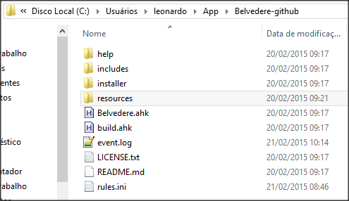
Double click on “Belvedere.ahk” to run it.
Config Belvedere.
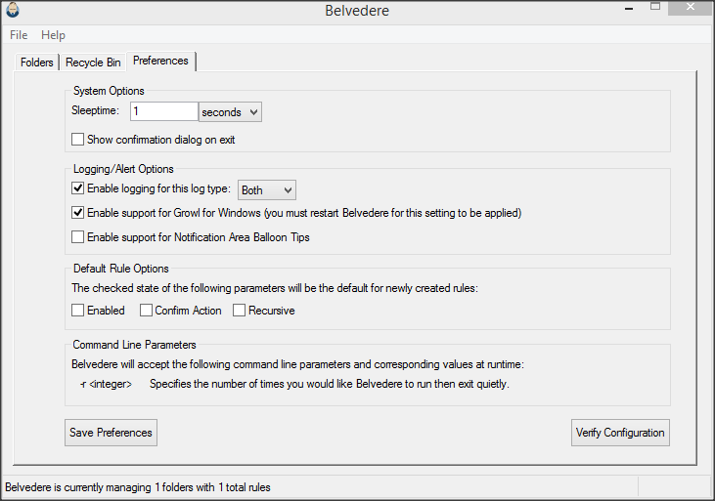
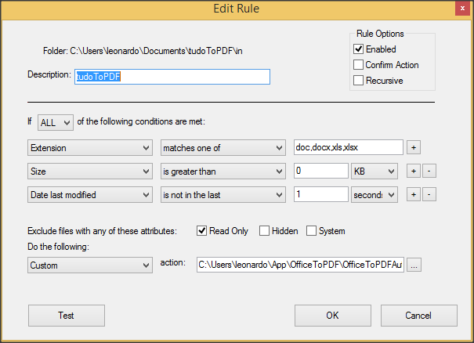

The custom action points to a batch file:
@echo on
:: get file name from complete path in var FILEOUT
for %%F in (%1) do SET FILEOUT=%%~nxF
:: move file to a "proc" folder to avoid multiple detections from belvedere
move %1 "C:\Users\leonardo\Documents\tudoToPDF\proc\"
"C:\Users\leonardo\App\OfficeToPDF\OfficeToPDF.exe" /bookmarks /hidden /markup /readonly /print /verbose "C:\Users\leonardo\Documents\tudoToPDF\proc\%FILEOUT%" "C:\Users\leonardo\Documents\tudoToPDF\out\%FILEOUT%.pdf" > "C:\Users\leonardo\Documents\tudoToPDF\log\%FILEOUT%.log" 2>&1
:: remove the proc input file
del "C:\Users\leonardo\Documents\tudoToPDF\proc\%FILEOUT%"

Batch file trusts on this folder structure. You can adjust paths to your needs.
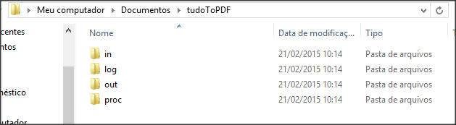
In -> user / other software copy office files to this folder (input)
Log -> conversion logs
Out -> generated pdf files
Proc -> staging temporary area

At this point you can try manually copy a file to “in” folder and should have corresponding PDF on “out” folder.

As we need to run Belvedere as a Windows service, you need to download and install Windows Server Resource Kit Tools (http://www.microsoft.com/en-us/download/details.aspx?id=17657).

Create a service pointing to “srvany.exe” using “instsrv”.
instsrv.exe Belvedere-OfficeToPDF C:\Users\leonardo\App\ResKitTools\srvany.exe

Config manually the service. First from services.msc – to use a normal system account. This account will be called “Office Account”.
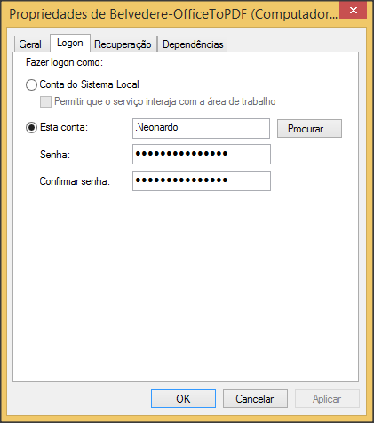

The use regedit to add parameters to “srvany.exe” service. Again, please adjust your paths.
REGEDIT4
[HKEY_LOCAL_MACHINE\SYSTEM\CurrentControlSet\Services\Belvedere-OfficeToPDF\Parameters]
"Application"="C:\\Program Files (x86)\\AutoHotkey\\AutoHotkey.exe"
"AppParameters"="C:\\Users\\leonardo\\App\\Belvedere-github\\Belvedere.ahk"
"AppDirectory"="C:\\Users\\leonardo\\App\\Belvedere-github"

After double click the reg file, please check inside regedit.
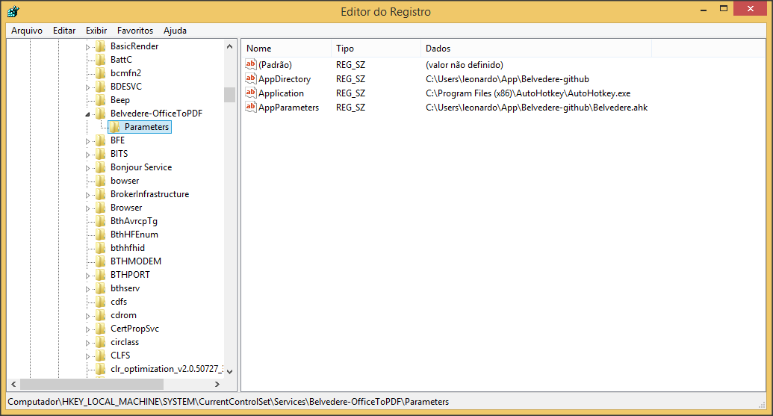

By now, Belvedere service must be up and running, but you still need to configure “Office Account” in DCOMCNFG to MSOffice be executed correctly.
Please run “dcomcnfg” and configure the “Office Account” inside each office application.
MSWord:
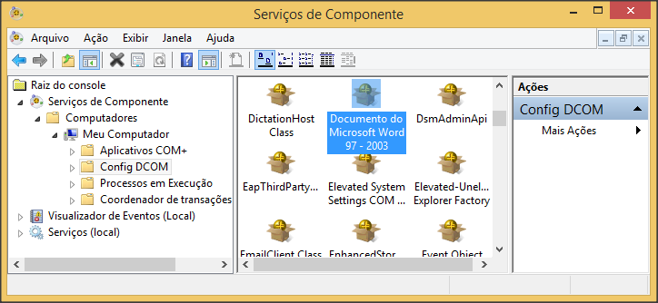
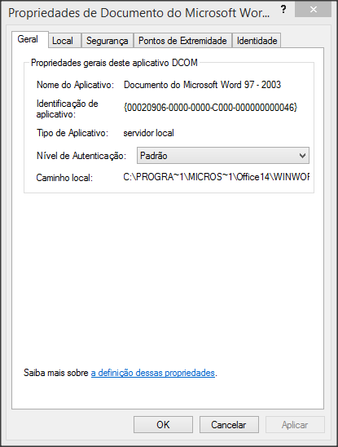
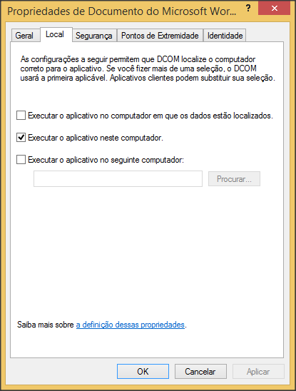
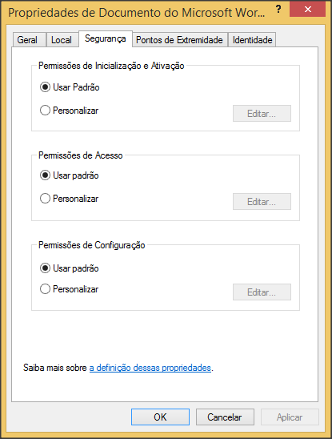
TODO – adjust Security Tab to use “custom” option and add “Office Account” inside each option with all privileges. This is needed if “Office Account” is not an administrator (recommended).

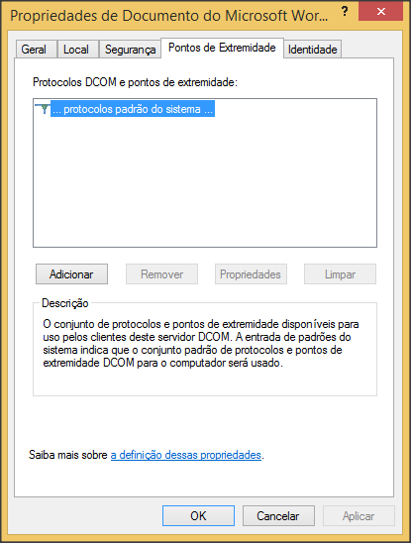
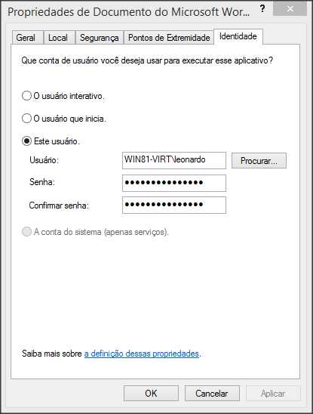
You need to configure Excel, PowerPoint etc the same way. Don’t forget to add the correct file extensions inside Belvedere rule.

Reboot your windows and try a conversion from a SMB shared folder. It should work without the user logged in.

